**How to collect observations with Google Earth App**

This document covers how to collect observations using **Google Earth app** in London or Barcelona. Use the **Google Earth** application each time you reach a location, or point of interest, you want to document. Collecting the coordinates of points of interest is called “**geotagging**”. Do this during your field trip in London or Barcelona to get the coordinates (i.e., latitude and longitude).

**Instructions for collecting coordinates from Google Earth App [You can watch a video for a guided demonstration (**[**CLICK HERE**](https://web.microsoftstream.com/video/8bb58f97-b403-485b-805d-4e94a068627e)**)]**

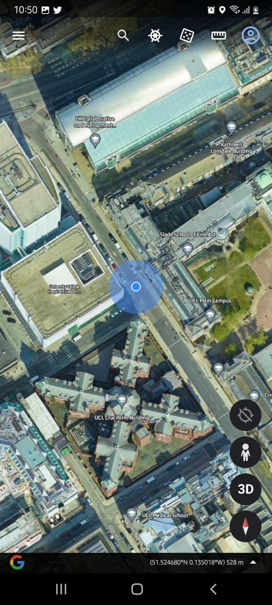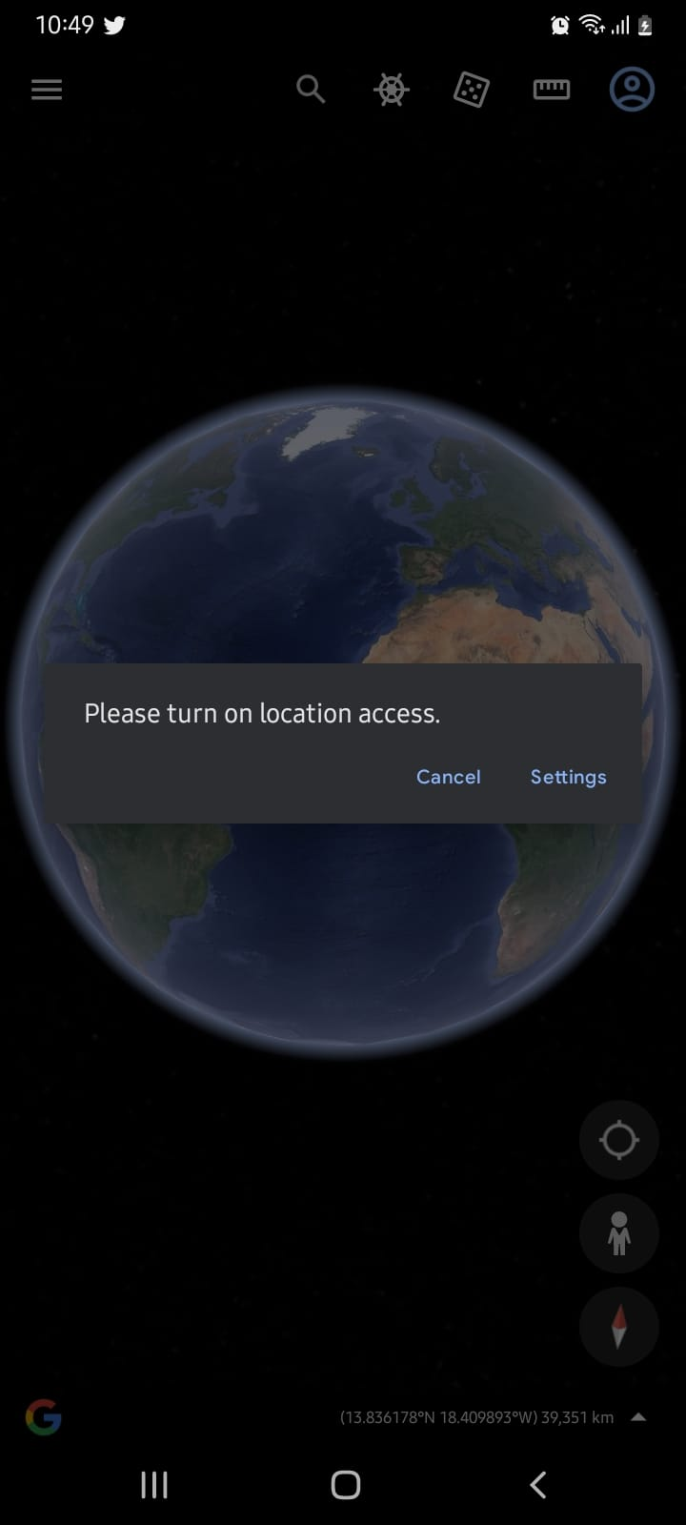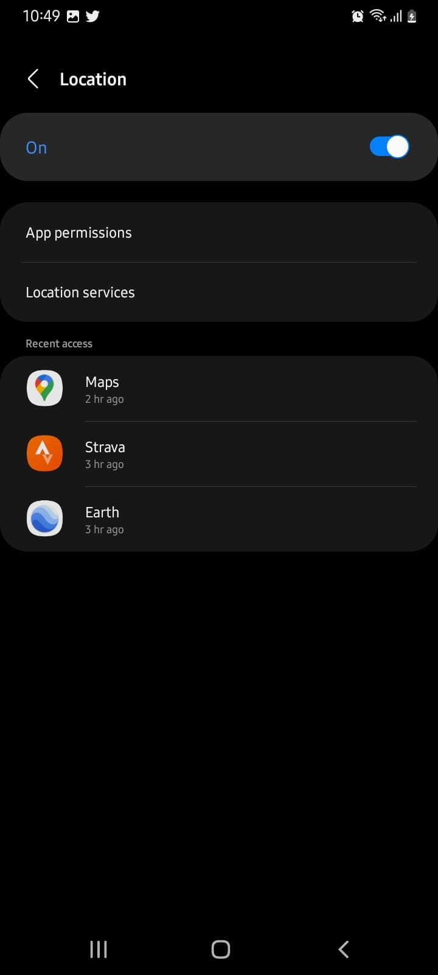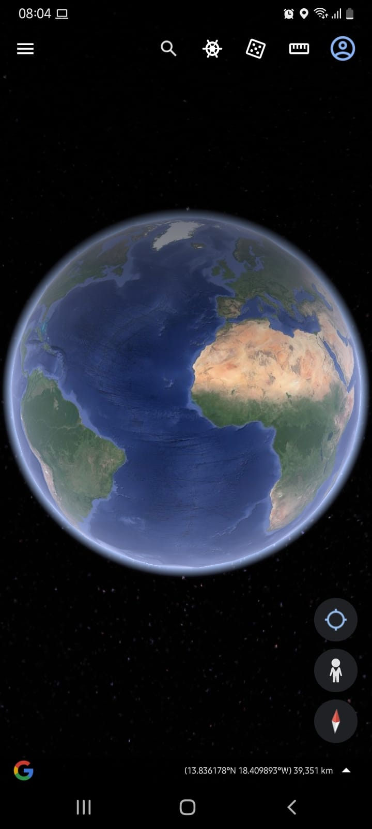

**Step 4: The app zooms into your location (after completing step 1 successfully). The blue is the approximate position of your location. At the bottom-right is the coordinates. This is what you want to document. Record your coordinates.**

**You can do this by taking a screenshot and adding an informative label to it, e.g., Site 1, Site 2 etc. Alternatively, write down the coordinates of each site you document in your field diary along with any observations and perhaps photos. You can take a screenshot as well.**

**Step 3: Turn the switch to “On” and go back to Step 1 and repeat.**

**Step 1: Click on the circular crosshair to find your current location. The app should zoom and hone-in to your position (If “Location Access” already on, then Jump to Step 4).**

**Note, the app won’t work if your “Location Access” on your phone is not switched on. You will be prompted to switch it one (go to Step 2)**

**Step 2: After clicking that circular crosshair a message “Please turn on location access” will appear if step 1 does not work. Please click on “Settings” to go into its menu to turn on the “Location Access” feature.**